DESIGN OF STRUCTURES
Quiz No. 3 (Data Sheet)

Part – A) Fill in the blanks with appropriate answers:

- All gravity loads are basically __________________ generated due to mass contained in a volume.
- Mechanism and path must be found to transfer loads to the _______________ through a Medium.
- Load Sharing is ________________ proportional to stiffness.
- Design Strip consist of ____________________
- The deflected surface of a one way slab is primarily one of __________________
- In one-way slab, the main reinforcement will be in __________ direction and the shrinkage & temperature reinforcement will be in _____________ direction.
- Both the flat slab and flat plate floors are characterized by the _________ of beams along the interior column lines.
- In flat plate floors, the shear strength is obtained by the embedment of multiple-U stirrups or structural steel devices known as ____________________
- Relatively, flat plate slabs are ___________ suitable for larger panel size or heavier loading than flat slabs.
- An elastic analysis (such as by the equivalent frame method) must be used for ____________ load even if the floor system meets the limitations of the direct design method for ____________ load.
- The total factored static moment, which states that, Absolute sum of positive and average negative factored moments in each direction shall not be less than M₀ = __________________________
- Total Factored Static Moment in Flat Slabs M₀ = __________________________
- It should be realized that the code provisions are based on a combination of _____________________
- The moment of inertia of a flanged beam section about its own centroidal axis I_{b} =
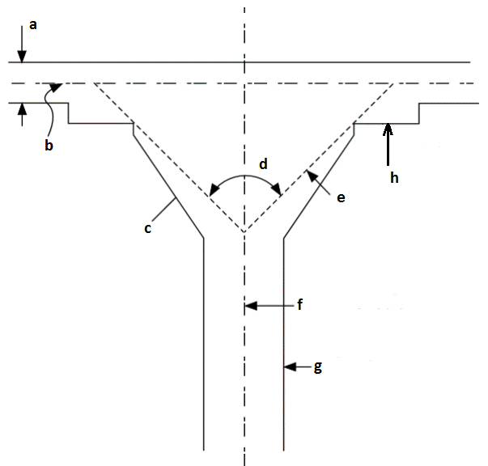
- For slabs supported on beams, there must be an edge beam at discontinuous edges having a stiffness ratio α not less than ______________
- The minimum thickness of Slab Supported on Beams is _____________
- The minimum thickness of flat plate slab is ___________
- The minimum thickness of flat slab is ___________
- Label the components of Flat slab: a___________b _______________
c _______________ d _________________ e___________________
f _______________ g _________________ h ___________________
- The diameter of the column capital is usually about ___________% of the average span length between columns.
- The projection of the drop panel below the slab must be at least _____________ of the slab thickness outside of the drop.
- When a qualifying drop is used, the minimum thickness has been reduced by ____________% from the minimum when a drop is not used.
- If the ratio of dead load to live load is higher, the effect of pattern loadings will be _____________
- The column strip takes a ____________ share of the negative longitudinal moment than the positive longitudinal moment.
- The critical section for two way shear is located so that its periphery b_{o} is at a distance ___________ outside a column, concentrated load, or reaction.
- As in beams, this critical section of width b_{w} times the effective depth ‘d’ is located at a distance _______ from the face of the equivalent square column capital or from the face of the drop panel.
Part – B
Describe the Limitations of Direct Design Method.

