Experiment No. 02
Determination of shear strength parameters (cohesion and angle of internal friction) by shear box test.
Designation:
- ASTM D 3080-03
Scope:
- This test method covers the determination of shear strength of a soil sample under direct shear.
- Test conditions including normal stress and moisture environment are selected which represent the field conditions being investigated.
- This test method provides data useful in determining strength and deformation properties of cohesive soils.
- The results of the test may be affected by the presence of soil or rock particles.
Apparatus:
- Shear Device
- Shear Box
- Triaxial Compression Chamber
- Porous Inserts
- Loading devices
- Deformation Indicator
- Shear force measurement device
- Sample Extruder
- Specimen Size Measurement Devices
- Timer
- Balances
Schematic diagram of triaxial chamber
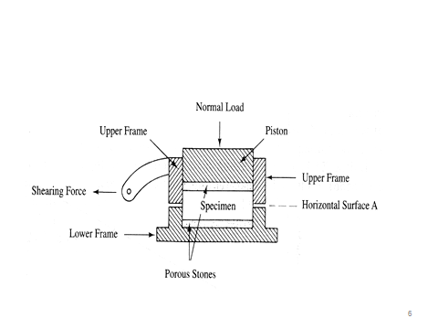
Procedure:
- Place a soil specimen in a relatively flat box, which may be round or square (Fig.)
- A normal load of specific (and constant) magnitude is applied
- The box is "split" into two parts horizon- tally (see Fig.), and if half the box is held while the other half is pushed with sufficient force, the soil specimen will experience shear failure along horizontal surface A.
- This procedure is carried out in a direct shear apparatus (Fig.), and the particular normal load and shear stress that produced shear failure are recorded.
- The soil specimen is then removed from the shear box and discarded, and another specimen of the same soil sample is placed in the shear box.
- A normal load differing from (either higher or lower than) the one used in the first test is applied to the second specimen, and a shearing force is again applied with sufficient magnitude to cause shear failure.
- The normal load and shear stress that produced shear failure are recorded for the second test.
- After failure remove the sample from the triaxial chamber and find out its moisture content for further calculations.
- The procedure is repeated for the new specimen for a different (either higher or lower) lateral pressure. The axial load at failure and the lateral pressure are recorded for the second test.
Graph Preparation:
- The results of these two tests are plotted on a graph, with normal stress (which is the total normal load divided by the specimen’s cross-sectional area) along the abscissa and the shear stress that produced failure of the specimen along the ordinate (see Fig.).
- The same scale must be used along both the abscissa and the ordinate.
- A straight line drawn connecting these two plotted points, is extended to intersect the ordinate.
- The angle between this straight line and a horizontal line (φ in Fig.) is the angle of internal friction (φ in Eq.), and the shear stress where the straight line inter- sects the ordinate (c in Fig.) is the cohesion [c in Eq.].
- These values of φ and c can be used in Eq. to determine the given soil’s shear strength for any load (i.e., for any effective inter granular normal pressure,).
- In theory, it is adequate to have only two points to define the straight- line relationship of Fig. In practice, however, it is better to have three (or more) such points through which the best-fitting straight line can be drawn.

