Alkali Silica Reactions (ASR)

Abstract
The traditional method of studying alkali-silica expansion reactions has been to cast rectangular prisms or cylinders of mortar or concrete, expose them to various regimens of temperature and moisture, and observe length changes of the specimens. While this approach yields information on expansion potential, it reveals nothing about the chemical reactions taking place in the mortar or concrete. In order to obtain samples of the pore solution in reacting mortars a pore fluid expression die was designed and built to operate at pressures up to 80,000 psi (552 MPa). These expressed solutions were then analyzed by atomic absorption spectroanalysis and microchemical methods. It was found that major chemical changes could take place in the pore solutions prior to the initiation of expansion and these changes frequently went to completion days or even months before expansion approached completion. Studies with pozzolans revealed that pore solution chemical changes associated with their reactions were similar to those associated with expansive reactions, but were generally much more rapid. Studies of the amount of water chemically bound by a unit weight of portland cement revealed that water chemically bound by portland cement is apparently reduced as a linear function of the ratio of pozzolan to cement. Data from a study of the effect of the presence of available calcium on the diffusion of potassium in opal suggests that, in the presence of calcium, the amount of potassium found in the outer layers of the opal may be nearly ten times as great as that in the absence of calcium.

This topic covers the following contents:
- ASR …. Concrete Cancer
- Introduction to ASR
- How ASR takes place…???
- Contribution of alkali to ASR
- Contribution of silica to ASR
- ASR Mitigation measures
- How is ASR look like…???
- Detection of ASR…
- Minimizing the effects of ASR

ASR …. Concrete Cancer
When water remains in contact with the concrete masses for a large time 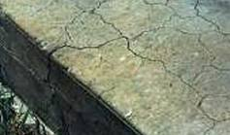 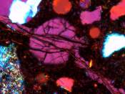
Then ASR is activated and a white powder like gel is produced due to this reaction. When this gel swells in the concrete then cracks occur due to which more water enters in concrete and the reaction becomes heavily.
ASR is time taking reaction. Mostly it is found in water reservoirs such as dams, barrages etc. So ASR is a concrete cancer, because if it is not cured it will react badly & results will be in harsh damages to the structures.

Alkali Silica reaction is the chemical result of the alkaline in the cement and the silicon in the aggregate reacting with one another and giving way to the concrete cracking open, in general, in a star formation. When the concrete cancer appears this can then lead to other problems, these being things like enabling water to penetrate the concrete to a deeper level, which, especially in winter can cause major problems as in freeze/thaw action causing the concrete to break up even more. There are way to prevent this during the construction stage which are set out in B.S. 8110:Part 1:1985, but there aren't an methods as yet to prevent it in structures that have already been constructed.
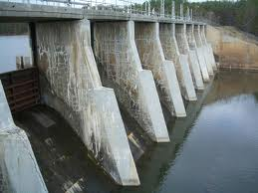
So far over the last twenty or so years there have been no more major signs of the concrete cancer appearing in the newer buildings which have been produced, but there is always time.

Introduction to ASR
Alkali-silica reaction (ASR) is one of the most recognized deleterious phenomena
in concrete. ASR is a chemical reaction between the reactive silica contained in the
Aggregates and the alkalis (Na2O and K2O) within the cement paste. The result is an
Alkali-silicate gel that absorbs water and increases in volume. If the gel is confined
by the cement paste, it builds up pressure as it grows causing internal stresses that
eventually could crack the concrete.

Identifying the susceptibility of an aggregate to alkali-silica reaction (ASR) before
using it in concrete is one of the most efficient practices for preventing damage.
Several tests have been developed to identify aggregates subject to ASR, but each
has its limitations. A three-year research study was initiated on January 1, 1998 at
the University of Texas at Austin for investigating ASR in portland cement concrete.
The study was approved by the ICAR advisory of directors on November of 1997.
The scope of the study is essentially two fold: 1) develop more accurate testing
protocols for identifying aggregates which are subject to ASR and 2) develop
mitigation methods for preventing ASR damage in concrete in case a reactive
aggregate had to be used.

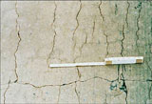

Alkali-silica reaction (ASR) is a reaction that takes place between the reactive
silica contained in aggregates and the alkalis in the cement paste. For the reaction to
take place in concrete, three conditions must exist: high pH, moisture, and reactive
silica. Various types of silica present in aggregates react with the hydroxyl ions
present in the pore solution in concrete. The silica, now in solution, reacts with the
sodium (Na+) and potassium (K+) alkalis to form a volumetrically unstable alkalisilica
gel. Once formed, the gel starts imbibing water and swelling to a greater
volume than that of the reacted materials. Water absorbed by the gel can be water
not used in the hydration reaction of the cement, free water from rain, snowmelt,
tides, rivers, or water condensed from air moisture In general, the
reaction can be viewed as a two-step process

Step 1:

Silica + alkali alkali-silica gel (sodium silicate)
SiO2 + 2NaOH + H2O Na2SiO3.2H2O (2KOH can replace 2NaOH)

Step 2

Gel reaction product + water expansion

Since the gel is restrained by the surrounding mortar, an osmotic pressure is
generated by the swelling. Once that pressure is larger than the tensile strength of
the concrete, cracks occur leading to additional water migration or absorption and
additional gel swelling

What is ASR…

Alkali-silica reaction takes place between reactive siliceous minerals in certain aggregates and OH- ions in the cement paste. Alkalis (Na+ and K+) from the cement, mixing water, or environment increase the concentration of OH- ions in the concrete. The OH- ions attack susceptible aggregate minerals. The damaged framework forms a gel that absorbs water from the surrounding concrete. The gel expands, generating pressures that can crack the concrete. The damage may not be visible to the naked eye for years after the concrete has been placed.
The ASR reaction is the same as the Pozzolanic reaction which is a simple acid-base reaction between calcium hydroxide, also known as Portlandite, or (Ca(OH)₂), and silicic acid (H₄SiO₄, or Si(OH)₄). For the sake of simplicity, this reaction can be schematically represented as following:
Ca(OH)₂ + H₄SiO₄ → Ca²⁺ + H₂SiO₄²⁻ + 2 H₂O → CaH₂SiO₄ · 2 H₂O
This reaction causes the expansion of the altered aggregate by the formation of a swelling gel of Calcium Silicate Hydrate (CSH). This gel increases in volume with water and exerts an expansive pressure inside the material, causing spalling and loss of strength of the concrete, finally leading to its failure.
So, ASR can cause serious expansion and cracking in concrete, resulting in critical structural problems that can even force the demolition of a particular structure.^{[3]}
The mechanism of ASR causing the deterioration of concrete can be described in four steps as follows:
- The alkaline solution attacks the siliceous aggregate to convert it to viscous alkali silicate gel.
- Consumption of alkali by the reaction induces the dissolution of Ca²⁺ ions into the cement pore water. Calcium ions then react with the gel to convert it to hard calcium silicate hydrate.
- The penetrated alkaline solution converts the remaining siliceous minerals into bulky alkali silicate gel. The resultant expansive pressure is stored in the aggregate.
- The accumulated pressure cracks the aggregate and the surrounding cement paste when the pressure exceeds the tolerance of the aggregate .

CONTRIBUTION OF THE SILICA TO THE REACTIO

Various forms of silica or silicon oxide tetrahedron may be found in natural
aggregates. The silicon tetrahedron is shown in Figure 2.1 where Si4+ occupies the
center of the structure and four oxygen ions (O--), bonded to Si4+, occupy the corners
(Leming 1996). A crystalline silicate structure is formed by the repetition of the
silicon tetrahedron in an oriented three-dimensional space (Prezzi et al. 1997).
Quartz (SiO2) is an example of completely crystalline silica where the different
tetrahedra are linked by oxygen ions. Each oxygen ion is bonded to two silicons in
order to achieve electrical neutrality. Figure 2.2 shows the structure of quartz. A
complete tetrahedron cannot form on the surface of a crystalline structure. The
bonds between oxygen and silicon are broken on the surface resulting in negative
charges that are unsatisfied (Prezzi et al. 1997). Such structures are chemically and
mechanically stable, impermeable, and react only on the surface (Leming 1996).
Amorphous silicates (non-crystalline) are also formed by a combination of the silicon
tetrahedron with the exception that the tetrahedra are arranged in a random threedimensional
network without forming a regular structure (Prezzi et al. 1997). As a
result, amorphous silica is more porous, has a large surface area, and as a
consequence, is very reactive. The more amorphous the silica is, the more reactive it
becomes. Certain volcanic aggregates, for example, contain glassy materials formed
by the rapid cooling of melted silica that prevents it from crystallizing and renders it
very reactive (Leming 1996).
Contribution of Alkali to ASR
Depending on the type of reactive silica contained in aggregates, the alkali-silica
reaction can be divided into two groups.
Group A:
Alkali-silica reaction that occurs with amorphous (poorly crystalline)
silica minerals and volcanic or artificial glasses: Alkalis such as sodium (Na+) and
potassium (K+) present in the concrete paste will break the silica-oxygen bonds,
opening the crystal structure for alkalis and water. The result is a sodium silicate
hydrate (Na2SiO3.2H2O) that is very hygroscopic capable of imbibing large amounts
of water that in turn results in swelling pressures which, if larger than the concrete
Reactive aggregate content:
Percent by mass of total aggregate
0 20 40 60 80
0 1 2 3 4 5 6
A B C D
A,D = Reaction but no cracking
B = Reaction, cracking
C = Reaction, cracking, excess of
reactive silica
Reactive silica content:
Percent by mass of total aggregate
Expansion
tensile strength, will cause cracking. Cracks will allow the penetration of additional
water causing the swelling pressures to increase. This type of reaction is fairly fast
and can cause cracking within a few years.
Alkali-silica reaction that occurs with various variety of quartz such as
strained and fractured quartz: Aggregates in this group either contain moderately
reactive silica or contain a small amount of silica. Since the reactive silica in these
aggregates is localized at the surface, the resulting gel product is more stable because
of the presence of large amounts of calcium hydroxide at the interface between the
aggregate and paste. Porous aggregates are an exception, because the alkalis will
penetrate the aggregates causing a less stable gel to form away from the interface and
the calcium hydroxide. This process will cause the softening of the aggregates.
Damaging effects of this reaction on concrete are a slower and less obvious process
than the effects of Group A.
The higher the concentration of potassium and sodium alkalis in concrete the
higher the concentration of the hydroxyl ions (higher pH) and in turn the more
readily the silica will react with the hydroxyl ions (ACI 221, 1998). If all the
ingredients for the reaction are present in fresh concrete then the gel can often be
detected at the interface between the aggregate and cement paste. Cracks will start
propagating from the aggregate particles. However, if the alkalis are provided from
an exterior source such as deicing salts, seawater, and industrial solutions then the
reaction will propagate from the exposed faces to the interior of the concrete .

Where does it occur?
ASR-susceptible aggregates are found in most states in the US. However, when engineers are aware of susceptible aggregates, they can take appropriate preventive measures.

How ASR takes place

Various types of silica present in aggregates react with the hydroxyl ions present in the pore solution in concrete. The silica, now in solution, reacts with the sodium (Na+) and potassium (K+) alkalis to form a volumetrically unstable alkali silica gel. Once formed, the gel starts imbibing water and swelling to a greater volume than that of the reacted materials. Water absorbed by the gel can be water not used in the hydration reaction of the cement, free water from rain, snowmelt,tides, rivers, or water condensed from air moisture .
Conditions required for ASR…..
The conditions required for ASR to occur are:
- A sufficiently high alkali content of the cement (or alkali fromother sources)
- A reactive aggregate, such as chert
- Water - ASR will not occur if there is no available water in the concrete, since alkali-silica gel formation requires water.

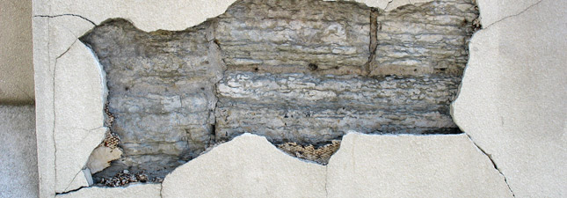

How to minimize the effects of ASR
If the aggregate is shown to be potentially reactive by these tests, some mitigation measure must be used to control the expansion and cracking. Low-alkali cements are sometimes recommended for this purpose, but they are not always the best or even an adequate solution. Some aggregates are too reactive to be controlled by a low-alkali cement. Also, alkalis can come from other sources besides the cement. It is better to use supplementary cementitious materials in some form to control the expansions:
- Blended cements containing Class F fly ash, natural pozzolans, calcined clay, silica fume, or slag may be used either alone or in combination with additional supplementary cementitious materials of the same or different type.
- Portland cement may be used with one or more supplementary cementitious materials. Lithium admixtures may also be used.
You should also verify that the control measure you have selected will do the job. For supplementary cementitious materials, conduct ASTM C 1260 again, this time with the job cement and supplementary cementitious material(s) in the proportions proposed. Not sure how much to use? In that case, test several combinations at the same time. For Class F fly ash, try mixes containing 15%, 20%, and 25% by weight of cement; for slag, try 40%, 45%, and 50%.
ASR MITIGATION MEASURES
Mitigating or preventing deleterious expansions caused by the alkali-silica
reaction can be achieved by:
- Limiting moisture:
The alkali-silica reaction will not take place in a concrete
structure if the internal relative humidity of the concrete is lower than 80%. As a
result, keeping the concrete dry will prevent the reaction from occurring.
However, this is practically impossible for exterior structures. Lowering the
permeability of concrete by reducing the water-cement ratio reduces the internal
moisture and delays the reaction. However, a low water-cement ratio results in a
higher cement content, higher alkali content, and a reduced pore space which
could lead to higher expansions (ACI 221, 1998). Lowering the permeability of
concrete using mineral admixtures is a more viable approach to reducing the
deleterious effects of ASR (ACI 221, 1998). Applying a protective coating to
concrete is a good solution provided that the coating is correctly installed.
Because of the high cost of concrete coatings, this method has been used on a
limited basis.
- Selecting Non-Reactive Aggregates:
Using a non-reactive aggregate in concrete
and avoiding reactive aggregates will prevent ASR damage. This demands an
accurate testing protocol capable of correctly predicting the ASR reactivity of
aggregates. Such tests exist but need more refining and improvements (ACI 221,
1998). This is not economical in some regions where all locally available
aggregates are considered reactive.
- Minimizing Alkalis:
The most commonly used mitigation method is to control
the alkali content in the concrete for the purpose of reducing the hydroxyl ion
concentration and eventually the pH of the concrete. Cement is the major source
of alkali in the concrete. Alkalis are also provided, in smaller amounts, from fly
ash, mixing water, chemical admixtures, aggregates, and external sources such as
deicing salts and seawater. Controlling the alkali content of the cement has been
28
proven to decrease the expansions caused by ASR. A proposed limit of 0.60%
has been recommended for the alkali content of cement to be used in concrete to
reduce ASR expansions . The maximum limit of 0.60% Na2Oequivalent in cement was the result of a study
initiated in 1940 by Stanton of the California Division of Highways (Hill 1996).
During the same period of time the Bureau of Reclamation imposed the same limit
on their “important” projects, basing their decision on the work conducted by Blanks
and Meissner in 1945. Although the Bureau of Reclamation concluded that a 0.50%
Na2O is a much safer limit, a 0.60% limit was considered adequately safe and more
economical. Several other research studies performed between 1941 and 1963,
namely by Tremper (1941 and 1944), Kammer and Carlson (1941), Woolf (1952),
Bryant Mather (1952), and Oleson (1963), all concluded that cement with alkali
contents lower than 0.60% have shown very little to no ASR damaging effects (Hill
1996).
Over the years, the 0.60% Na2Oequivalent limit in the cement has been proven to be
very effective in preventing concrete damage due to ASR. There are, however, some
instances where cements with Na2Oequivalent of less than 0.60% and even less than
0.40% have resulted in deleterious expansions due to ASR (Hill 1996). In 1978,
Starks discovered concrete pavements in southeastern Wyoming and pavement
sidewalks in the Albuquerque, New Mexico area that had been deteriorated, in less
than 12 years, due to excessive ASR expansions. The alkali content of the cements
used for these projects was just under the 0.60% Na2Oequivalent limit. He also noticed
that some older structures in these areas constructed using cements with alkali
contents of about 0.48% have shown no ASR damage while some of them have
shown some map cracking. This fact was also noted by the first ASR researchers of
30
the 1940s who noticed that some aggregates might cause deleterious effects even
with very low alkali content cements (Hill 1996).
While the emphasis in the United States was concentrated on limiting the alkali
content of the cement, some of the western European countries as well as Canada
were trying to limit the alkali content of the concrete including alkalis from the
cement, aggregates, mineral, and chemical admixtures (Hill 1996).
Since there is a large diversity in natural aggregates, there is no magic number
that can be specified for the alkali limit of cement in order to prevent alkali-silica
reaction in concrete. A combination of measures might have to be employed to
prevent the reaction and that includes the use of low alkali cement in combination
with a mineral admixture (Hill 1996).

- Mineral Admixtures:
Ever since the alkali-silica reaction was discovered,
researchers have reported on the effectiveness of mineral admixtures in reducing
its deleterious effects on concrete. Effective mineral admixtures include fly ash,
silica fume, ground granulated slag, and calcined clay. In addition, there exist
documents reporting structures over 25 years old, containing reactive aggregates
and 20 to 30 percent fly ash. Mineral admixtures reduce ASR expansions by one
or more of the following mechanisms:
􀂃 Reducing the alkali content of the concrete mix.
􀂃 Reducing the pH of the concrete pore solution.
􀂃 Consuming the calcium hydroxide, which might result in lower swelling.
􀂃 Reducing concrete permeability.
Testing for the effectiveness of mineral admixtures is a challenge. Researchers
have reported that ASTM C 441, Effectiveness of Fly Ash and Mineral Admixtures
in Reducing Deleterious ASR Expansions”, is not a valid test for investigating the
effectiveness of mineral admixtures (ACI 221, 1998). ASTM C 1260 has been
successfully used for this purpose. If ASTM C 1293 is to be used, a two-year
period is recommended for obtaining the final expansion results (ACI 221, 1998).
- Chemical Admixtures:
Lithium salts have been used to prevent excessive ASR
expansions. Several salts have been tried, some of which have shown to be
effective. The best results were obtained using lithium nitrate (LiNO3) because
1) it is non-toxic and
2) minimal amounts were found to significantly reduce the
ASR expansions .
- Air Entrainment:
It was reported that adding 4% of entrained air to concrete
reduced the ASR expansions by 40%. It was also noticed that the expanding gel
29
had filled the air void system. However, this method has not yet been thoroughly
investigated nor has it been used in the field .
Effectiveness of Supplementary Cementing Materials
The effectiveness of supplementary cementing materials (SCM) in suppressing
ASR in concrete has been a subject for extensive research for a long time. Various
researchers and authors have reported opposing results on their effectiveness mainly
because of the wide range of available fly ash types and the different properties and
reactivity of aggregates being investigated (Shayan et al. 1996).
To minimize the risk of damage due to alkali-aggregate reaction in concrete
containing reactive aggregates, current UK guidelines permit the use of fly ash.
However, definite advice on the use of fly ash in concrete and on percentages to use
is not included in the guidelines because there exists conflicting evidence regarding
the alkali content of the fly ash and whether these are available for reacting with the
aggregate causing additional ASR damage (Thomas, Blackwell, and Nixon 1996).
This is especially a concern when the total alkali content of the concrete is being
31
controlled below a certain level in order to prevent ASR damage. Several
recommendations exist on how to deal with the alkali content of fly ash including
(Thomas, Blackwell, and Nixon 1996):
1. The Concrete Society (UK) recommends using the water-soluble alkali content of
the fly ash for determining the total alkali content of the concrete, and
2. The Building Research Establishment (UK), Department of Transport (UK),
French Guidelines, and Ireland guidelines recommend using one-sixth of the total
alkali content of the fly ash to calculate the total alkali content of the concrete.
This is a more conservative approach since 0.40% to 0.70% Na2Oequiv. is
equivalent to 0.10% water-soluble alkali content.
Evidence from the literature show that the use of sufficient levels of Class F fly
ash is effective in preventing ASR expansions in concretes containing natural
reactive aggregates even when the alkalis from sources other than the fly ash are
enough to cause deleterious expansions in concretes without any fly ash (Thomas et
al. 1996). In this case, the fly ash is considered to have a positive effect and to have
no reactive alkali contribution. However, when moderate levels of fly ash are used
in concrete containing very rapidly reactive aggregates with low alkali content
cements, then the fly ash will likely contribute alkalis to the reaction. In this case,
higher replacement levels may be required in order for the fly ash to completely
prevent the reaction from causing damage (Thomas, Blackwell, and Nixon 1996).
In order to clarify these matters, Thomas, Blackwell, and Nixon (1996) reported
about a study where five reactive aggregate sources from the UK area were
investigated. Aggregates were used to make concrete specimens using one highalkali
portland cement (1.15% Na2Oequiv.) and three Class F fly ashes with varying
total alkali content (2.98, 3.46, and 3.86% Na2Oequiv.). Fly ash was used at different
replacement levels and concrete prisms were stored in plastic containers at 200C and
32
100% relative humidity. At 7 days, initial length measurements of all prisms were
taken before wrapping them in moist toweling and polyethylene. Some of the
wrapped prisms were stored at 200C while some were stored at 380C all at 100%
humidity. For the particular materials used in this study (UK reactive aggregates and
UK Cement and Class F fly ash) it was determined that (Thomas, Blackwell, and
Nixon 1996):
1. The effective alkali contribution of the ash depends upon the nature of the
reactive aggregate and the levels at which the weight of cement is replaced with
the fly ash.
2. The alkali content of concrete in the control specimens (neglecting the alkalis in
the fly ash) was enough to cause deleterious expansions and cracking of
specimens containing moderately reactive flint. Replacing the cement with 25%
fly ash was effective in reducing expansions. As a result, it was noted that the fly
ash has a positive effect in reducing damage due to AAR and does more then just
dilute the alkalis in the cement. Using the same reactive aggregate but replacing
6% of the cement with fly ash resulted in an increase in expansions for a given
cement alkali content. It was determined that 40% of the total alkalis in the fly
ash contributed to the expansions of concrete specimens.
Replacing 25% of the cement weight with fly ash was not effective in preventing
What does it look like?
Alkali-silica reaction is identified by characteristic three-armed cracks appearing on the surface of the concrete. The crack pattern may be altered due to restraint in one direction (as in a pavement), or due to other stresses from imposed loads. Sometimes you can see gel oozing from the cracks. A closer look shows that the cracks start from the aggregate particles.

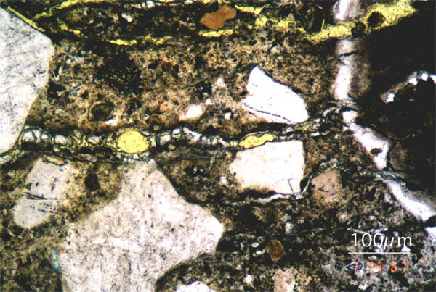
Figure 1 Concrete thin-section, viewed with a petrographic microscope, showing a chert aggregate particle (at the right of the image) from which alkali-silica gel has extruded into adjacent cracks.

There are other possible causes of three-armed cracks. To confirm that the cracks are caused by alkali-silica reaction, have a petrographer examine the concrete. A slightly magnified view of a polished surface will show reaction rims around the reactive aggregate particles. Signs of ASR include cracks originating from the reactive aggregate particles, discolored areas around the aggregate particles where ASR gel has stained the surrounding paste, and gel filling the cracks. The petrographer will also be able to identify the type(s) of reactive mineral(s) causing the problem.
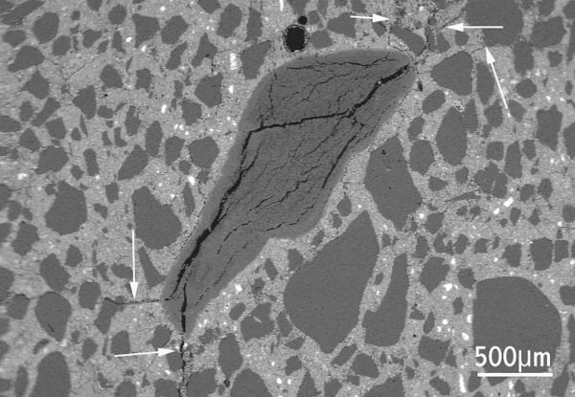
Figure 2 Polished section of concrete, viewed with a scanning electron microscope, showing a chert aggregate particle with extensive internal cracks due to ASR. The cracks extend from the aggregate into the nearby concrete (arrowed).
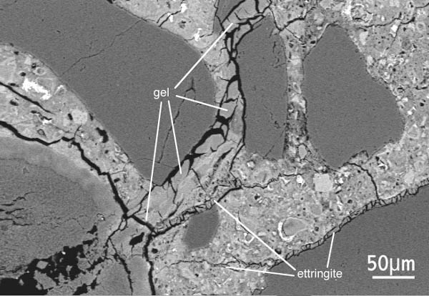
Figure 3 Detail of the chert particle in the previous image and adjacent cement paste, showing alkali-silica gel extruded into cracks within the concrete. Ettringite is also present within some cracks.
How is ASR Detected?
The first step is to determine whether the aggregates to be used on a project are susceptible to ASR. CTL can provide any or all of the tests required, as well as recommendations for how best to control any harmful expansions.
The Portland Cement Association recommends analyzing the aggregate according to ASTM C 295, "Standard Guide for Petrographic Examination of Aggregates for Concrete." If the aggregate contains more than the following quantities of any of these reactive minerals, it is considered potentially reactive:
- Optically strained, microfractured, or microcrystalline quartz exceeding 5.0%
- Chert or chalcedony exceeding 3.0%
- Tridymite or crystobalite exceeding 1.0%
- Opal exceeding 0.5%
- Natural volcanic glass in volcanic rocks exceeding 3.0%
It is helpful to give this list to the petrographer so s/he knows how much of each constitutent is considered problematic.
In addition, the aggregate should also be tested according to ASTM C 1260, "Standard Test Method for Potential Alkali Reactivity of Aggregates (Mortar-Bar Method)." Any aggregate having a 14-day expansion greater than 0.10% is considered potentially reactive.
If the aggregate is determined to be potentially reactive by either of these tests, it may be further evaluated by ASTM C 1293, "Standard Test Method for Determination of Length Change of Concrete Due to Alkali-Silica Reaction." An aggregate having a 1-year expansion greater than 0.04% is considered potentially reactive.
How can I test for alkali-silica reactivity (ASR)?
Alkali-silica reactivity is the process in which certain minerals (mostly glass type silica) in the presence of moisture are broken down by the highly alkaline environment of concrete producing a gel that expands creating tensile forces in the concrete matrix which cause cracking of the concrete. The cracking then allows more water to infiltrate into the concrete creating more gel, more expansion etc. Ultimately the concrete fails or disintegrates.
Table: Test Methods for Alkali-Silica Reactivity (Source: Farny and Kerkhoff, 2007)
Test Name | Purpose | Type of Test | Duration of Test | Comments
ASTM C 227,  Potential alkali-reactivity of cement-aggregate combinations (mortar-bar method) | To test the susceptibility of cement-aggregate combinations to expansive reactions involving alkalies | Mortar bars stored over water at 37.8°C (100°F) and high relative humidity | Varies: first measurement at 14 days, then 1, 2, 3, 4, 6, 9, and 12 months; every 6 months afterthat as necessary | Test may not produce significant expansion, especially for carbonate aggregate. Long test duration. Expansions may not be from AAR.
ASTM C 289,  Potential alkali-silica reactivity of aggregates | To determine potential reactivity of siliceous aggregates | Sample reacted with alkaline solution at 80°C (176°F). | 24 hours | Quick results. Some aggregates give low expansions even though they have high silica content. Not reliable.
ASTM C 294,  Constituents of natural mineral aggregates | To give descriptive nomenclature for themore common or important natural minerals—an aid in determining their performance | Visual identification | Short duration—as long as it takes to visually examine the sample | These descriptions are used to characterize naturally-occurring minerals that makeup common aggregate sources.
ASTM C 295,  Petrographic examination of aggregates for concrete | To outline petrographic examination procedures for aggregates—an aid indetermining their performance | Visual and microscopic examination of prepared samples—sieve analysis, microscopy, scratch or acid tests | Short duration—visual examination does not involve long test periods | Usually includes opticalmicroscopy. Also may include XRD analysis, differential thermal analysis, or infrared spectroscopy—see ASTM C 294 for descriptive nomenclature.
ASTM C 342,  Potential volume change of cement-aggregate combinations | To determine the potential ASR expansion of cement-aggregate combinations | Mortar bars stored in water at 23°C (73.4°F) | 52 weeks | Primarily used for aggregates from Oklahoma, Kansas, Nebraska, and Iowa.
ASTM C 441,  Effectiveness of mineral admixtures or GBFS inpreventing excessive expansion of concrete due to alkali-silica reaction | To determine effectiveness of supplementary cementing materials in controlling expansion from ASR | Mortar bars—using Pyrex glass as aggregate—stored over water at 37.8°C (100°F) and high relative humidity | Varies: first measurement at 14 days, then 1, 2, 3, 4, 5, 9, and 12 months; every 6 months after that as necessary | Highly reactive artificial aggregate may not represent real aggregate conditions. Pyrex contains alkalies.
ASTM C 856,  Petrographic examination of hardened concrete | To outline petrographic examination procedures for hardened concrete—useful in determining condition or performance | Visual (unmagnified) and microscopic examination of prepared samples | Short duration — includes preparation of samples and visual and microscope examination | Specimens can be examined with stereomicroscopes,polarizing microscopes, metallographic microscopes, and scanning electron microscope.
ASTM C 856 (AASHTO T 299),  Annex uranyl- acetate treatment procedure | To identify products of ASR in hardened concrete | Staining of a freshly-exposed concrete surface and viewing under UV light | Immediate results | Identifies small amounts of ASR gel whether they cause expansion or not.Opal, a natural aggregate, and carbonated paste can glow—interpret results accordingly.Tests must be supplemented by petrographic examination and physical tests for determining concrete expansion
Los Alamos staining method (Powers 1999) | To identify products of ASR in hardened concrete. | Staining of a freshly-exposedconcrete surface with two different reagents. | Immediate results
ASTM C 1260 (AASHTO T303),  Potential alkali reactivity of aggregates (mortar-bar method) | To test the potential for deleterious alkali-silica reaction of aggregate in mortar bars | Immersion of mortar bars in alkaline solution at 80°C (176°F) | 16 days | Very fast alternative to C 227. Useful for slowly reacting aggregates or those that produce expansion late in the reaction.
ASTM C 1293,  Determination of length change of concrete due to alkali-silica reaction (concrete prism test) | To determine the potential ASR expansion of cement-aggregate combinations. | Concrete prisms stored over water at 38°C (100.4°F) | Varies: first measurement at 7 days, then 28and 56 days, then 3,6,9,and 12 months; every 6 months as after that as necessary | Preferred method of assessment. Best represents the field. Requires long test duration for meaningful results. Use as a supplement to C 227,C 295, C 289, and C 1260. Similar to CSA A23.2-14A.
ASTM C 1567, Potential alkali-silica reactivity of combinations of cementitious materials and aggregate (accelerated mortar-bar method) | To test the potential for deleterious alkali-silica reaction of cementitious materials and aggregate combinations in mortar bars | Immersion of mortar bars in alkaline solution at 80°C (176°F) | 16 days | Very fast alternative to C 1293. Allows for evaluation of effectiveness of supplementary cementitious materials.
