Experiment No. 03
Determination of Shear Strength Parameters (cohesion and angle of internal friction) by Tri-axial compression test.
Designation:
- ASTM D 4767-02
Scope:
- This test method covers the determination of strength and stress-strain relationships of a cylindrical specimen.
- This test method provides for the calculation of total and effective stresses, and axial compression by measurement of axial load, axial deformation and pore water pressure.
- This test method provides data useful in determining strength and deformation properties of cohesive soils.
Apparatus:
- Axial Loading Device
- Axial Load-Measuring Device
- Triaxial Compression Chamber
- Axial Load Piston
- Pressure Control Device
- Specimen Cap and Base
- Deformation Indicator
- Rubber Membrane
- Sample Extruder
- Specimen Size Measurement Devices
- Timer
- Balances
Schematic diagram of triaxial chamber
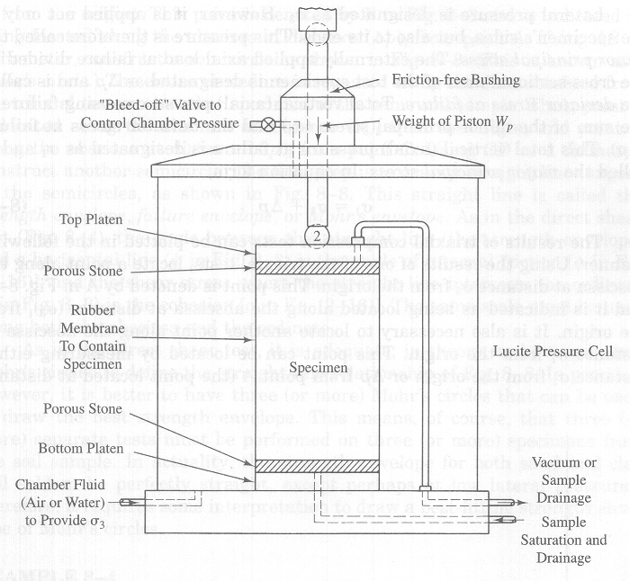

Procedure:
- Extrude the soil sample from Shelby Tube Sampler.
- Cut a soil sample such that the ratio “L/D” lies in between 2 and 2.5.
- Measure the exact diameter of top of the specimen at three different locations (120º apart), both at top and bottom of the sample and take the average diameter from the above measurements.
- Measure the exact length of the specimen at three different locations and take its average value.
- Weigh the sample on a weighing balance
- Wrap the cylindrical soil specimen in a rubber membrane.
- Carefully place the specimen in the triaxial chamber and centre it on the bottom plate.
- Apply a specific (and constant) lateral pressure by means of water or compressed air within the chamber.
- Next, a vertical (axial) load is applied externally and steadily increased until the specimen fails.
- The externally applied axial load that causes the specimen to fail and the lateral pressure are recorded.
- After failure remove the sample from the triaxial chamber and find out its moisture content for further calculations.
- The procedure is repeated for the new specimen for a different (either higher or lower) lateral pressure. The axial load at failure and the lateral pressure are recorded for the second test.
Graph Preparation:
- Lateral pressure is designated as σ3. However, it is applied not only to the specimen's sides, but also to its ends. This pressure is therefore called the minor principal stress
- The externally applied axial load at failure divided by the cross-sectional area of the test specimen is designated as Δp and is called the deviator stress at failure
- Total vertical (axial) pressure causing failure is the sum of the minor principal stress (σ3) and the deviator stress at failure (Δp). This total vertical (axial) pressure at failure is designated as σ1 and is called the major principal stress. In equation form
σ1 = σ3 + Δp
- Using the results of one of the triaxial tests, locate a point along the abscissa at distance σ3 from the origin. This point is denoted by A in Fig., and it is indicated as being located along the abscissa at distance (σ3)1 from the origin.
- It is also necessary to locate another point along the abscissa at distance σ1 from the origin. This point can be located by measuring either distance σ1 from the origin or Δp from point A (the point located at distanceσ3 from the origin). This point is denoted by; B in Fig. and is indicated as being located along the abscissa at distance (Δp)1 from point A.
- Using AB as a diameter, construct a semicircle as shown in Fig. (This is known as a Mohr's circle.)
- The entire procedure is repeated using the data obtained from the triaxial test on the other specimen of the same soil sample
- Thus, point C is located along the abscissa at distance (σ3)2 from the origin, and point D along the abscissa at distance (Δp)2 from point C. Using CD as a diameter, construct another semicircle.
- The final step is to draw a straight line tangent to the semicircles, as shown in Fig. This straight line is called the strength envelope, failure envelope, or Mohr's envelope.
- The angle between this straight line (the strength envelope) and a horizontal line (φ in Fig.) is the angle of internal friction [φ in Eq.], and the shear stress where the straight line intersects the ordinate (c in Fig.) is the cohesion [c in Eq.].
- The same scale must be used along both the abscissa and the ordinate.
- Theoretically, it is adequate to have only two Mohr's circles to define the straight-line relationship. In practice, however, it is better to have three (or more) Mohr's circles that can be used to draw the best strength envelope.
- Practically, the strength envelope for both sand and clay will seldom be perfectly straight, except perhaps at low lateral pressures; therefore, it requires some interpretation to draw a best-fitting strength envelope of Mohr's circles.

Shear diagram for triaxial compression test:
